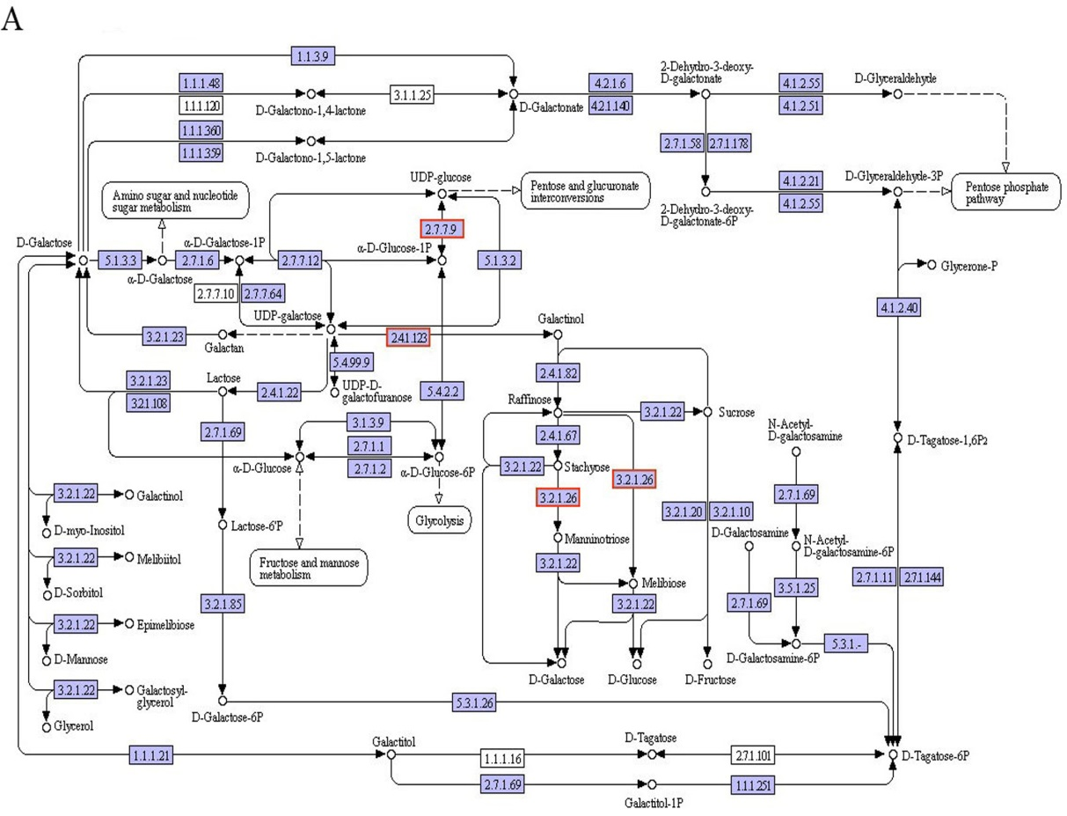

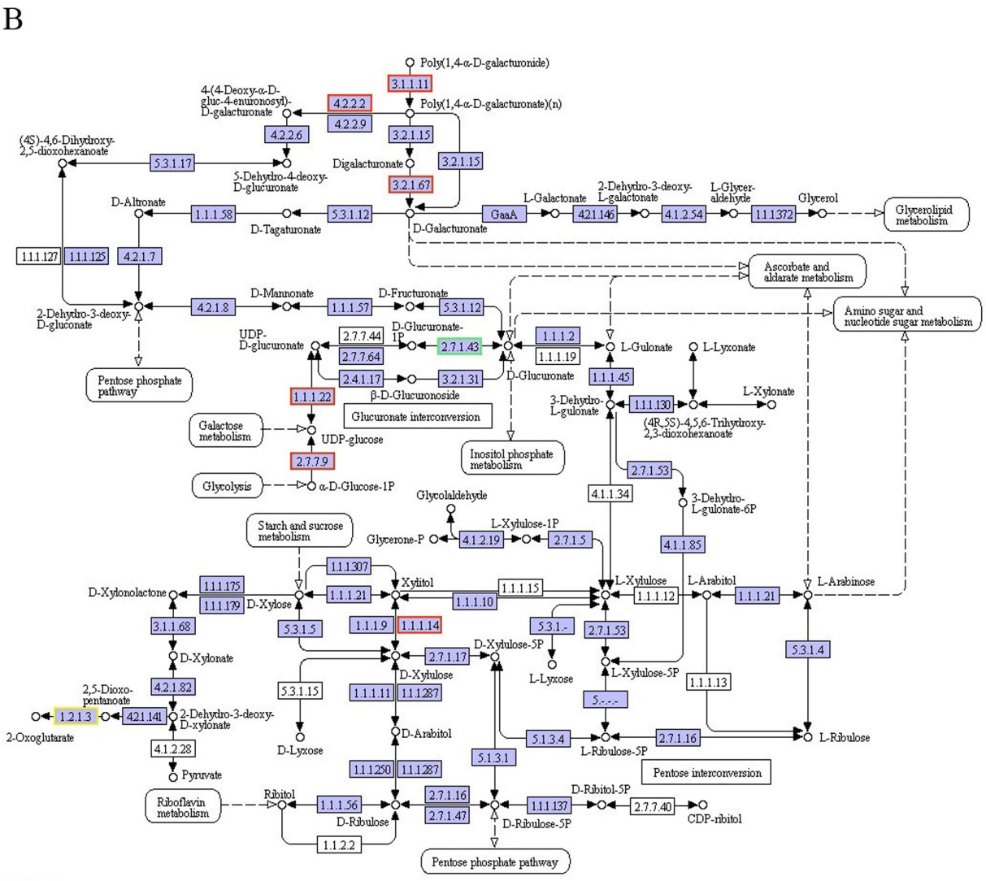

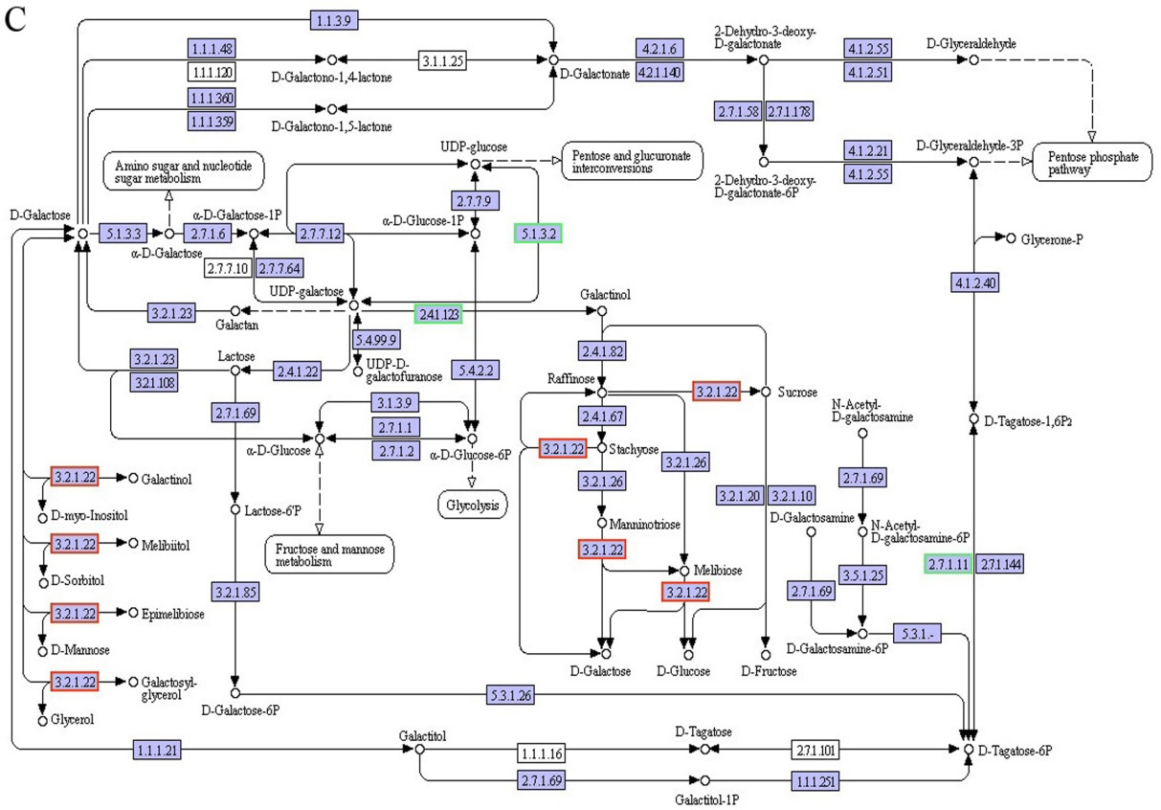

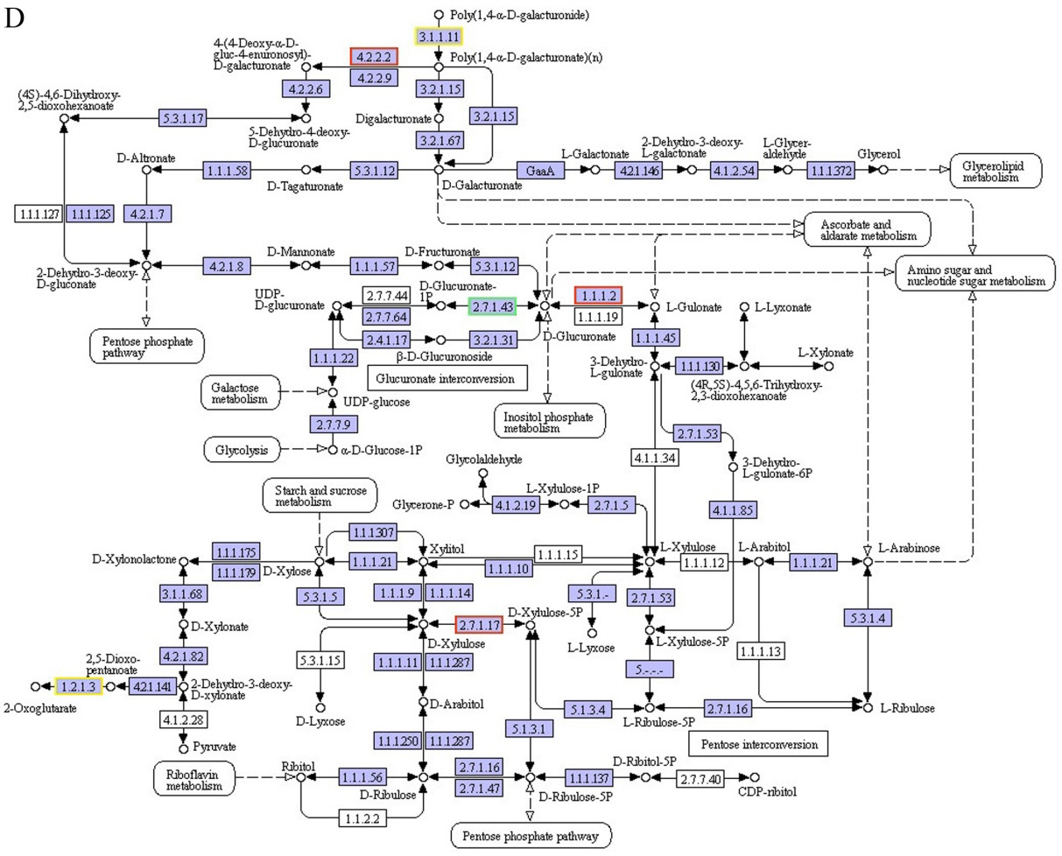

Fig. S3 DEGs assigned to “galactose metabolism” and “pentose and glucuronate interconversions” pathways in “T3 vs R” and “T4 vs H”. a: “galactose metabolism” pathway in “T3 vs R”; b: “pentose and glucuronate interconversions” pathway in “T3 vs R”; c: “galactose metabolism” pathway in “T4 vs H”; d: “pentose and glucuronate interconversions” pathway in “T4 vs H”; Red box：up-regulated genes; cyan box：down-regulated genes; yellow box：up-regulated and down-regulated genes.

